**Assignment - 2**

**Data Visualization and Data Preprocessing**

|  |  |
| --- | --- |
| Assignment Date | 21.09.2022 |
| Student Name | Sheikh Ameenul Haji |
| Student Roll Number | 2019115094 |
| Maximum Marks | 2 Marks |

**Task-1:**

Download the dataset.



**Task-2:**

Load the dataset.

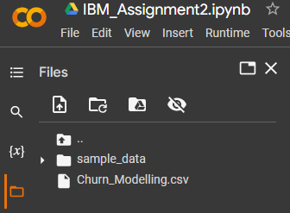

**Solution:**

df = pd.read_csv("Churn_Modelling.csv")

df.head()

#-----------------#

#-----------------#

**Screenshot:**

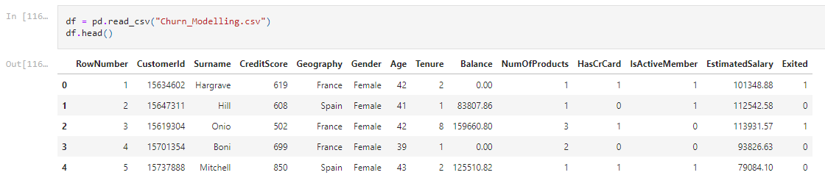

**Task-3:**

Perform Univariate, Bivariate, Multivariate analysis.

**Univariate analysis solution:**

sns.distplot(df['CreditScore'])

#-----------------#

#-----------------#

**Screenshot:**

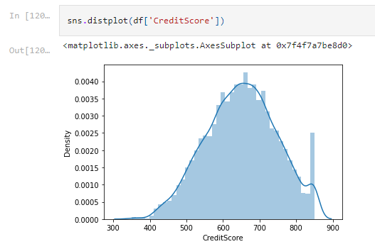

**Bivariate analysis solution:**

sns.lineplot(df['CreditScore'],df['EstimatedSalary'])

**Screenshot:**

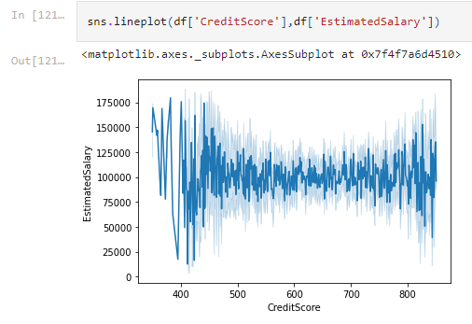

**Multivariate analysis solution:**

sns.pairplot(df)

#-----------------#

#-----------------#

**Screenshot:**

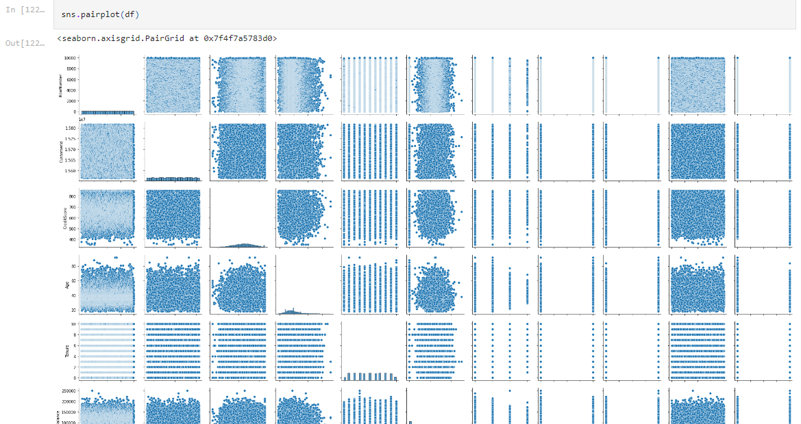

**Heatmap solution:**

sns.heatmap(df.corr())

#-----------------#

#-----------------#

**Screenshot:**

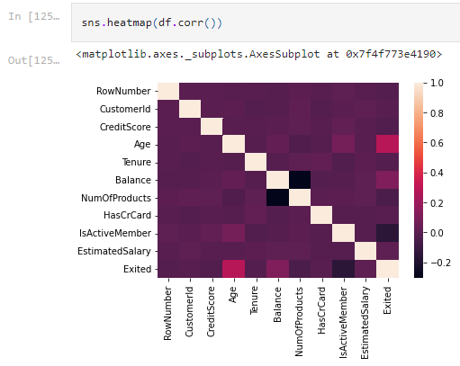

**Correlation solution:**

df.corr()

#-----------------#

#-----------------#

**Screenshot:**

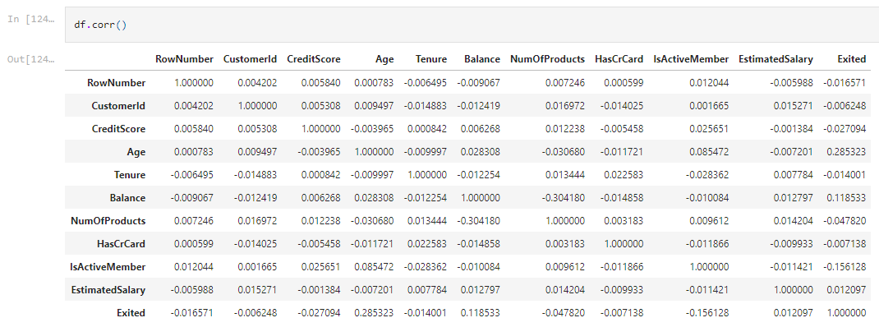

**Task-4:**

Perform descriptive statistics on the dataset

**Solution:**

df.describe()

#-----------------#

#-----------------#

**Screenshot:**

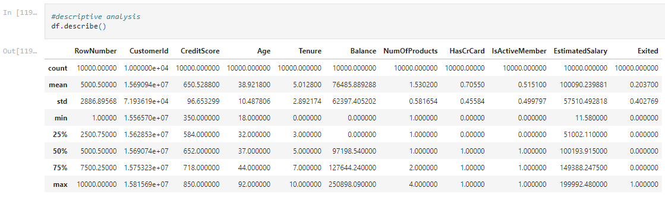

**Task-5:**

Handle the Missing values.

**Solution:**

#check for null values

df.isnull().any()

df['CreditScore'].fillna(df['CreditScore'].mean(),inplace=True)

df['Age'].fillna(df['Age'].median(),inplace=True)

df['Tenure'].fillna(df['Tenure'].median(),inplace=True)

df['Balance'].fillna(df['Balance'].median(),inplace=True)

df['CreditScore'].fillna(df['CreditScore'].median(),inplace=True)

df['NumOfProducts'].fillna(df['NumOfProducts'].median(),inplace=True)

df['HasCrCard'].fillna(0,inplace=True)

df['IsActiveMember'].fillna(0, inplace=True)

df['EstimatedSalary'].fillna(df['EstimatedSalary'].mean(), inplace=True)

#-----------------#

#-----------------#

**Screenshot:**

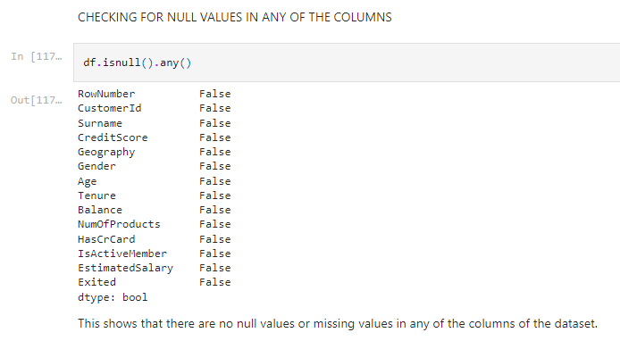

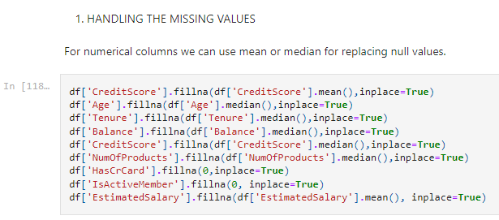

**Task-6:**

Find the outliers and replace the outliers

**Solution:**

#detecting outliers

sns.boxplot(df['Age'])

#replacing outliers

Q1= df['Age'].quantile(0.25)

Q3=df['Age'].quantile(0.75)

IQR=Q3-Q1

upper_limit =Q3 + 1.5*IQR

lower_limit =Q1 - 1.5*IQR

# df=df[df['Age']<upper_limit]

df['Age'] = np.where(df['Age']>upper_limit,37,df['Age']) #median 37

#-----------------#

#-----------------#

**Screenshot:**

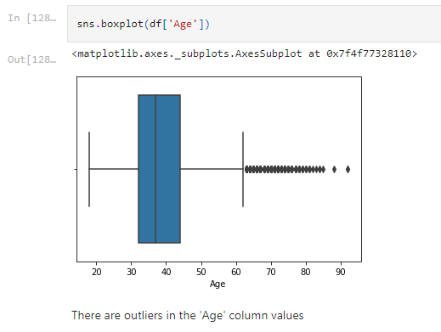

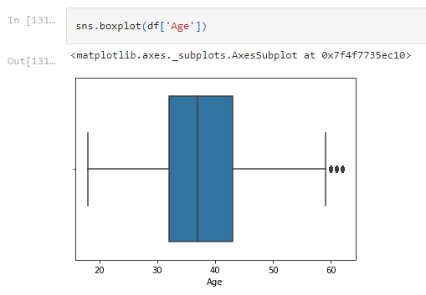

**Task-7:**

Check for Categorical columns and perform encoding.

**Solution:**

**#check for categorical columns**

textualColumns = [x for x in df.columns if df[x].dtype == np.dtype('O')]

print(textualColumns)

#perform label encoding to gender column

from sklearn.preprocessing import LabelEncoder

lbEnc=LabelEncoder()

df['Gender'] = lbEnc.fit_transform(df['Gender'])

#perform one hot encoding to Geography column

df_main=pd.get_dummies(df,columns=['Geography'])

df_main_main=df_main.drop(columns=['Surname'], axis=1)

df_main_main.head(10)

#-----------------#

#-----------------#

**Screenshots:**

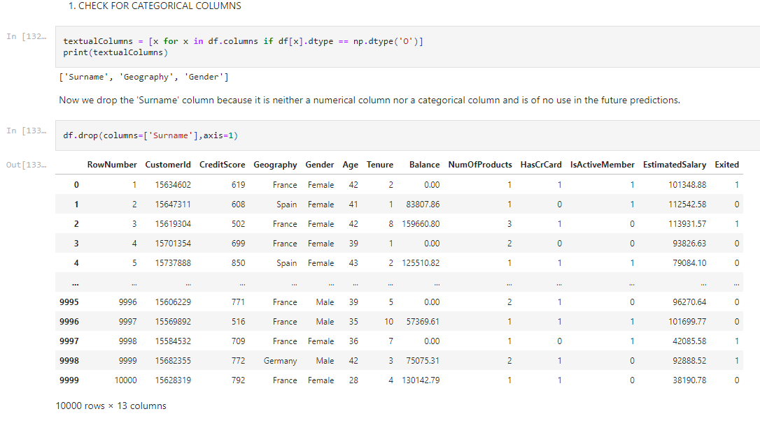

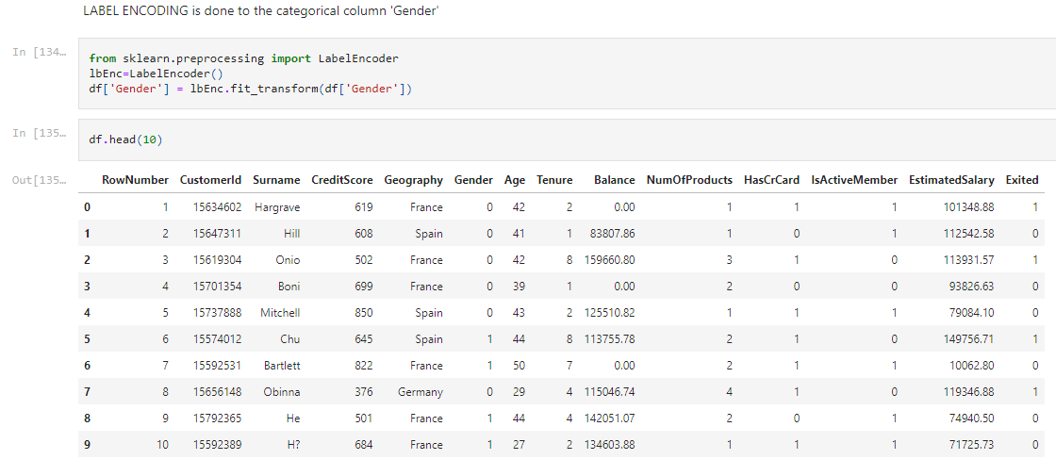

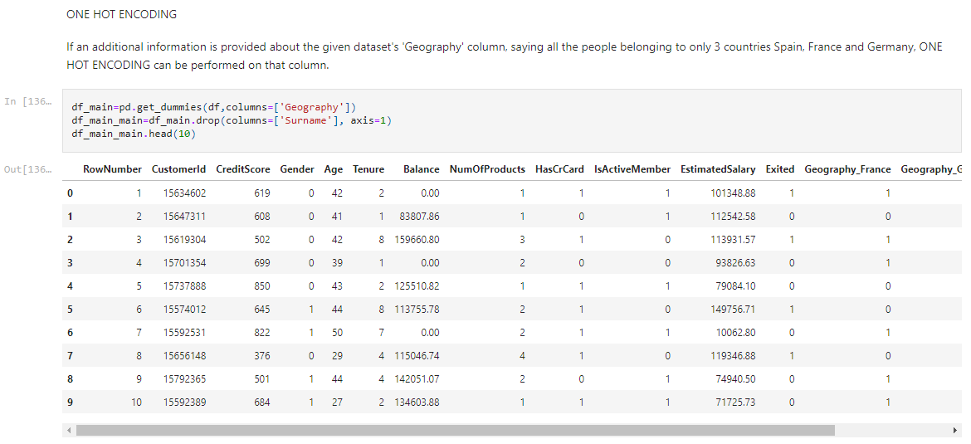

**Task-8:**

Split the data into dependent and independent variables.

**Solution:**

X=df_main_main.drop(columns=['EstimatedSalary'],axis=1)

X.head()

Y=df_main_main['EstimatedSalary']

print(Y)

#-----------------#

#-----------------#

**Screenshots:**

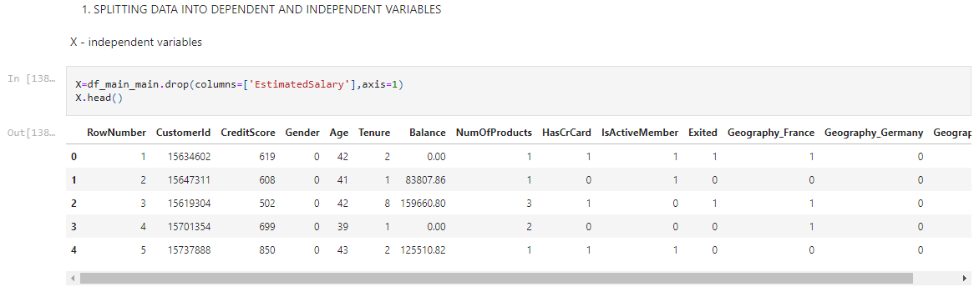

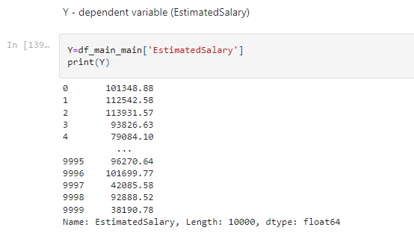

**Task-9:**

Scale the independent variables

**Solution:**

from sklearn.preprocessing import scale

X_scaled=pd.DataFrame(scale(X),columns=X.columns)

X_scaled.head()

#-----------------#

#-----------------#

**Screenshot:**

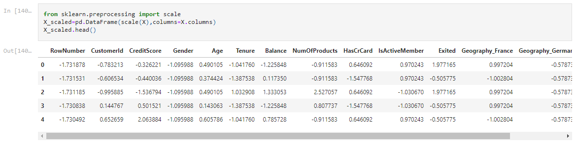

**Task-10:**

Split the data into training and testing

**Solution:**

from sklearn.model_selection import train_test_split

X_train,X_test,Y_train,Y_test =train_test_split(X_scaled,y, test_size=0.3,random_state=0)

print(X_train.shape)

X_train

#-----------------#

#-----------------#

**Screenshot:**

